The Board
Base Resources Limited
Level 3, 46 Colin Street,
West Perth, WA, 6005
P.O Box 928, West Perth
BC 6872, Australia
Phone +618 9413 7400
Email: info@baseresources.com.au

10th March 2023

RE: Letter from Villagers in Kwale County, Kenya, Raising Serious Concerns about the Exploratory Drilling Being Conducted by Base Titanium Limited / Base Resources Limited (Australia) in Our Ancestral Lands

We, the residents of several villages in Msambweni Sub-county, Kwale County, urgently call upon the Board of Base Resources, to address our concerns regarding the mining-related activities of your subsidiary, Base Titanium Ltd., in our ancestral lands.

Questionable Licensing Process

We would like to begin by stating that Base Titanium Ltd. was issued with a “Special Prospecting Licence” (No. 173) on 26th May 2016 under the old Mining Act – six days after the new Mining Act had been gazetted, and a day before the new Act came into effect (Annexes 1a and 1b).

Questionable Prospecting Process

According to Section 37(1) of the Mining Act: "A prospecting and mining rights shall not be granted under this Act with respect to private land without the express consent of the registered owner, and such consent shall not be unreasonably withheld."

However, the exploratory drilling that is presently being conducted by Base Titanium Ltd. in Kwale is not being done in good faith, but rather, in an unprofessional and intimidatory manner, under police escort, and using "divide and rule" tactics, in order to obtain consent from landowners. This is not only causing tension and animosity in the community, but even within families, as relatives are pitted against each other. The situation is becoming more serious by the day and those opposed to exploratory drilling are now concerned about their safety.

According to your company’s website, this amounts to "inappropriate misconduct" by company staff, which includes "behaviour or practices that may cause harm to its host communities." (Re: Whistleblower Standard –
https://baseresources.com.au/sustainability/sustainability-policies-and-standards/)

Primary Concern

Our primary reason for opposing exploratory drilling is that we do not want to lose our ancestral lands, as this project will only serve to enrich a few individuals and shareholders, at the expense of our community, our environment, and even the larger Kenyan populace.

We are also concerned by the fact that the license that was issued to Base Titanium Ltd. is the same one that was issued to Tiomin Resources Inc. in 1997, then simply renewed over the years (Annex 1). It is therefore to be expected that the same may apply to Base Titanium’s Environmental Impact Assessment (EIA) report. What makes this all the more likely is that despite official requests to Base Titanium Ltd. [under the Access to Information Act, 2016 (https://www.docdroid.net/KdCHyQl/second-official-request-for-the-environmental-impact-assessment-eia-submitted-by-base-titanium-limited-for-its-present-mining-operations-in-kwale-county-kenya-docx), the company has refused to provide the community with copies of their EIA (https://www.docdroid.net/HgxJYE8/response-from-base-titanium-limited-regarding-requests-for-copies-of-the-companys-environmental-impact-assessment-docx).

In closing, we wish to state that our grievances have previously been aired by local media sources (Re: https://youtu.be/Z0BVYPZm4A4 and https://citizentv.co.ke/news/wakazi-wa-vumba-kaunti-ya-kwale-walalamikia-vumbi-180988/) and recorded in a community meeting about five years ago: https://www.youtube.com/watch?v=znk_iWUpTHI For more background information, please see:- Case Study in Kenya: The Titanium Issue - https://madaraka.online/case-study-the-titanium-issue/

We look forward to your urgent intervention in this serious matter.

Thank you. Most Sincerely,

Mzee Omari Shee Mbega
Chairman, Committee of Gazi Location
Contact email: wanyeekinuthia@gmail.com

On behalf of:
The communities of Gazi, Vumbu, Maumba, Magaoni, Fihoni, Majikuko, Mwaloya, Bumamani, Madongoni, Masindeni, Mwandimu, and Zigira.

Copied to:

1. Hon. Salim Mvurya
Cabinet Secretary
Ministry of Petroleum and Mining
Email: cs@petroleumandmining.go.ke

2. Kenya National Commission on Human Rights
Email: complaint@knchr.org / coast@knchr.org / vkamau@knchr.org

Annex 1a

The Special Prospecting Licence (No. 173) Issued to Base Titanium Ltd.
Under the old Mining Act (Cap 306)

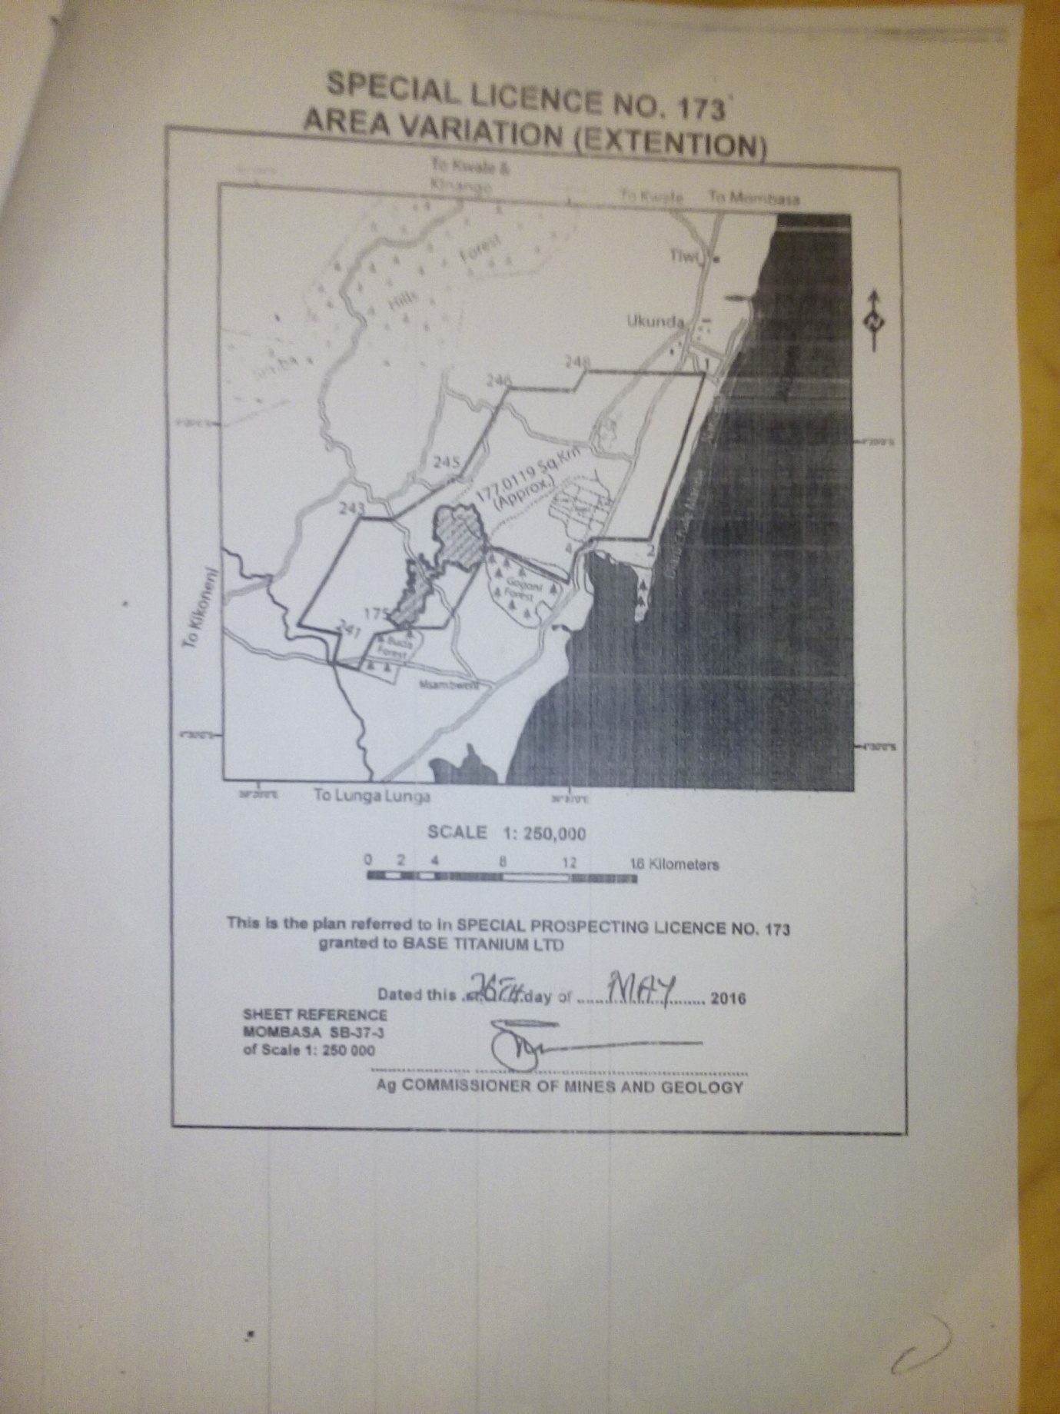

Annex 1b

The Special Prospecting Licence (No. 173) Issued to Base Titanium Ltd.
Under the old Mining Act (Cap 306)

